Images of our 2020 June journey to The Hedges on Blue Mtn. Lake, NY

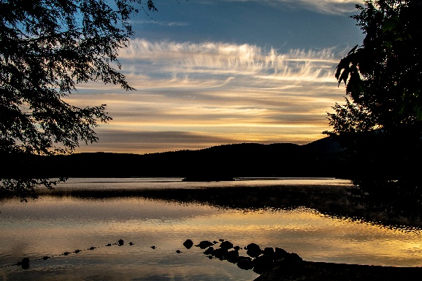

Since the summer of 1994, we have visited The Hedges annually on various dates and seasons. This trip to The Hedges on Blue Mountain Lake happened in June.

For photos, click [The Hedges – June 2020](https://photos.app.goo.gl/x1kF7nQ7uoa4iLNUA).

https://photos.app.goo.gl/x1kF7nQ7uoa4iLNUA